**Mobility Management**

Mobility management in the vehicle primarily focuses on how the bot’s movements are controlled and coordinated based on sensory input and motor actuation. The system architecture is designed to ensure smooth navigation, obstacle avoidance, and accurate response to arena conditions during both the **Open Challenge** and the **Obstacle Challenge**.

**Sensors and Control Input**

The main sensory unit integrated into the bot is the **LG PC 1080P camera module**, strategically trained according to the gameplay rules of the arena. The vision of this camera is segmented into **five regions of interest (ROI)** as shown in Figure.1:

* **A –** Left Wall/ Corridor Detection Zone
* **B –** Left Zone (White/Black Detection for Turns)
* **C –** Central Zone (Color Line Detection & Lap Counting)
* **D –** Right Zone (White/Black Detection for Turns)
* **E –** Right Wall/ Corridor Detection Zone

1. **Two regions (A & E)** are dedicated to **wall/corridor detection**, enabling the bot to remain center-aligned by maintaining equal spacing from the arena boundaries.
2. **Two regions (B & D)** are used for detecting **black/white zones**, which assist in identifying turning points, thereby enabling smooth cornering and avoiding collisions.
3. The **fifth region ©** is dedicated to **color line detection**. The first detected color is considered as the reference, and the bot counts laps based on it until the completion of three laps in the Open Challenge round. This ensures consistent movement either in a clockwise or anticlockwise direction, while ignoring the alternate color line.

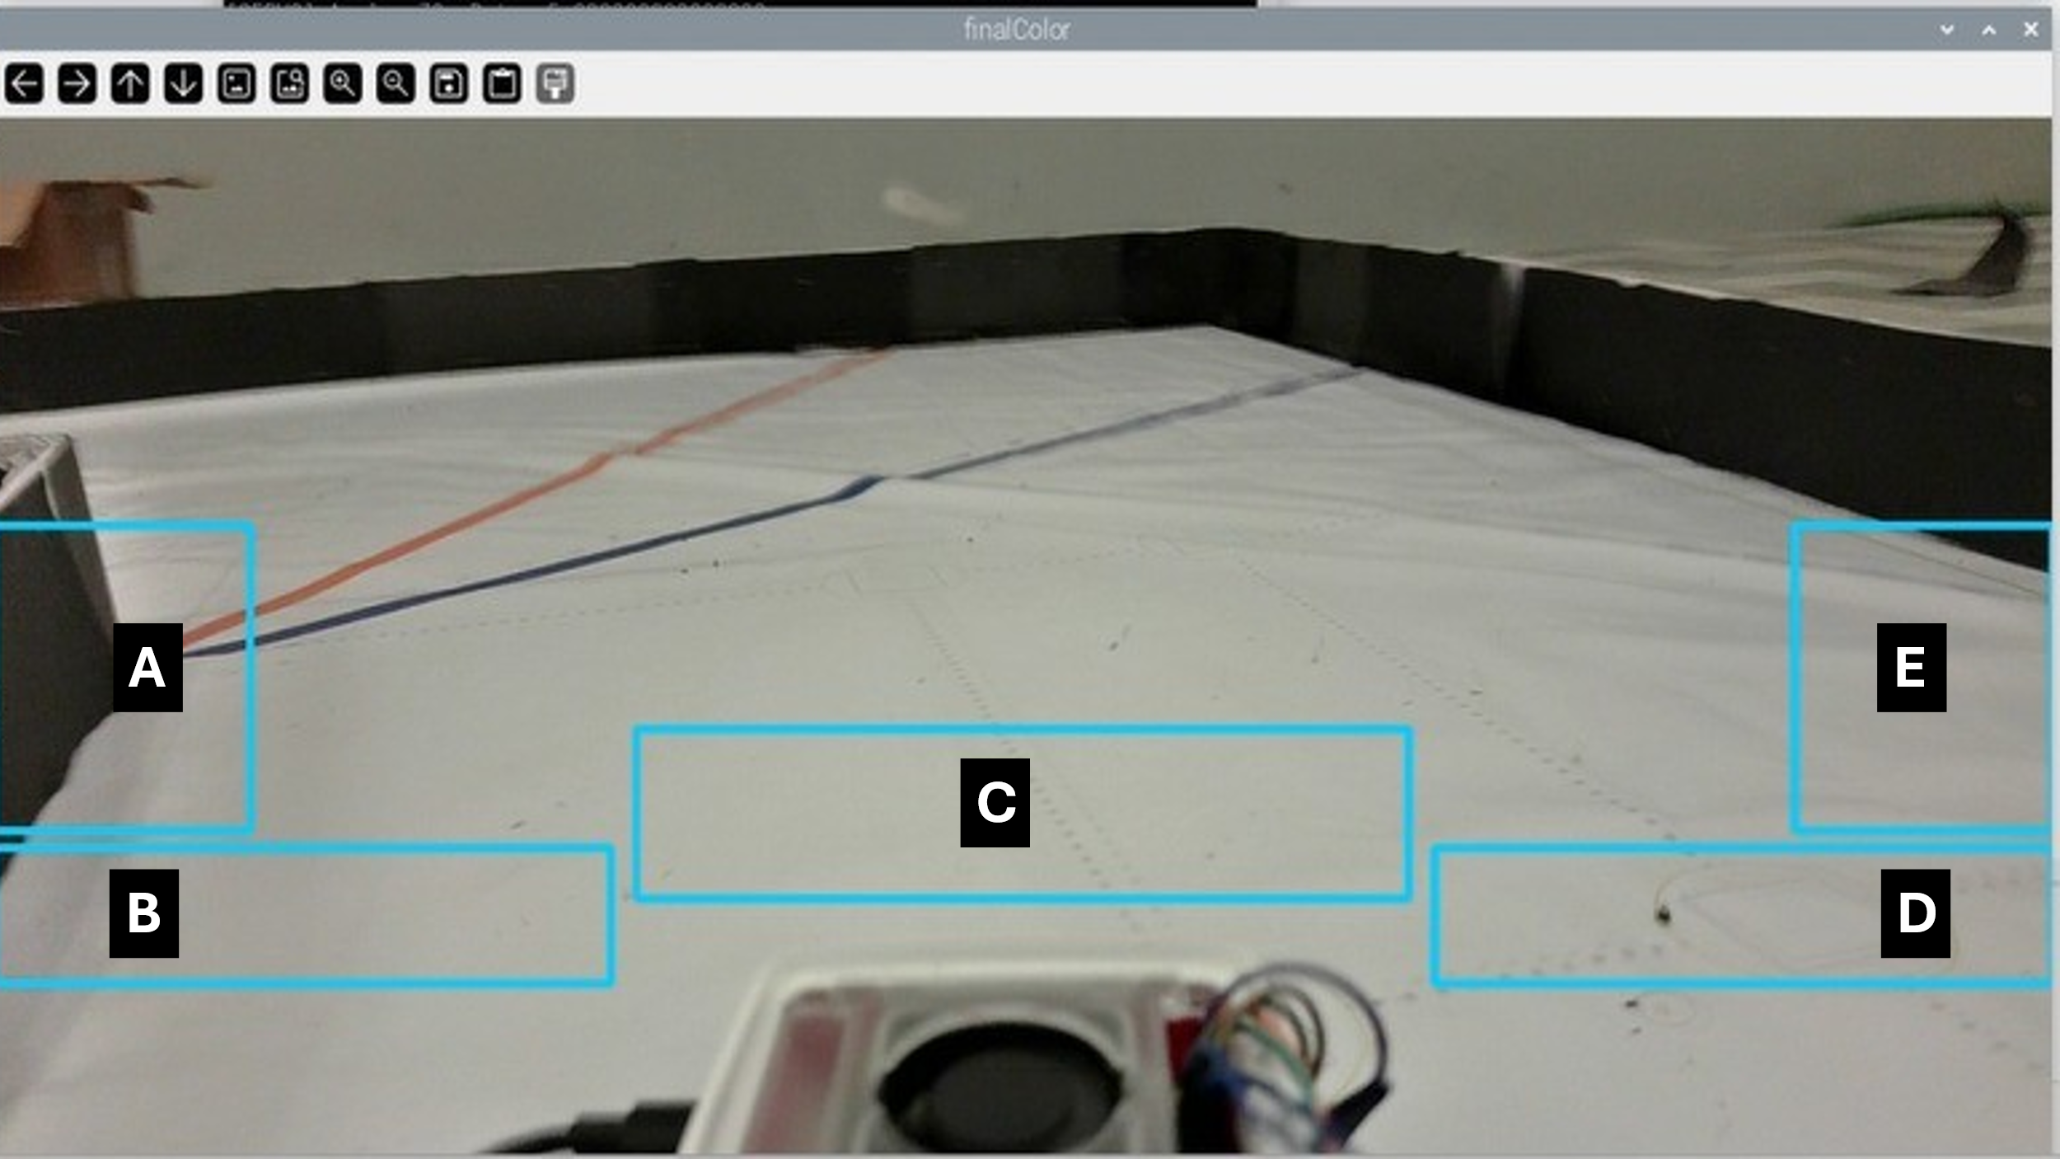

Fig.1: Camera Vision ROI Segmentation

Additionally, a **Raspberry Pi 5 MP camera module** is mounted at the rear side of the chassis, specifically for assisting in **reverse movement and parking operations**.

All sensory inputs from the cameras are processed by the **Raspberry Pi 5 (8 GB)** microcontroller unit. This controller was selected as it provides the necessary computational power, memory, and accuracy to handle real-time image processing and motor control with minimal discrepancies.

**Actuation and Motor Selection**

The bot is equipped with **two types of motors**, carefully chosen to meet torque, speed, and functionality requirements:

1. **Steering Motor – High Torque Servo Motor (180° rotation):**
   * Used to control the steering mechanism of the bot.
   * Provides precise angular control, ensuring smooth and accurate turning while transitioning between arena sections.
   * High torque capability ensures reliable steering under load and during sharp maneuvers.
2. **Driving Motor – DC Motor:**
   * Mounted to the rear wheels of the vehicle for forward and reverse locomotion.
   * **Anticlockwise rotation** → forward movement.
   * **Clockwise rotation** → backward movement (used mainly for parking in designated zones).
   * Selected for its balance of speed and torque, suitable for stable linear motion within the arena.

The **integration of motors with the sensory system** ensures that the bot reacts dynamically to the environment, aligning, turning, or reversing as per the detected input.

**Chassis Design and Fabrication**

The chassis was **custom-developed using 3D CAD software** to precisely meet the dimensional specifications outlined for the competition challenges. The design process emphasized:

* **Compactness and adaptability**, enabling the bot to effectively perform in both Open and Obstacle challenge scenarios.
* **Systematic placement of all components**—including cameras, microcontroller, motors, and wiring—ensuring a clean layout that avoids clutter while maintaining functional interconnections.
* **Iterative refinement through multiple design trials and error corrections**, resulting in a final optimized structure ready for assembly and deployment.

The finalized model, with all major components labelled, is shown in **Figure.2.**

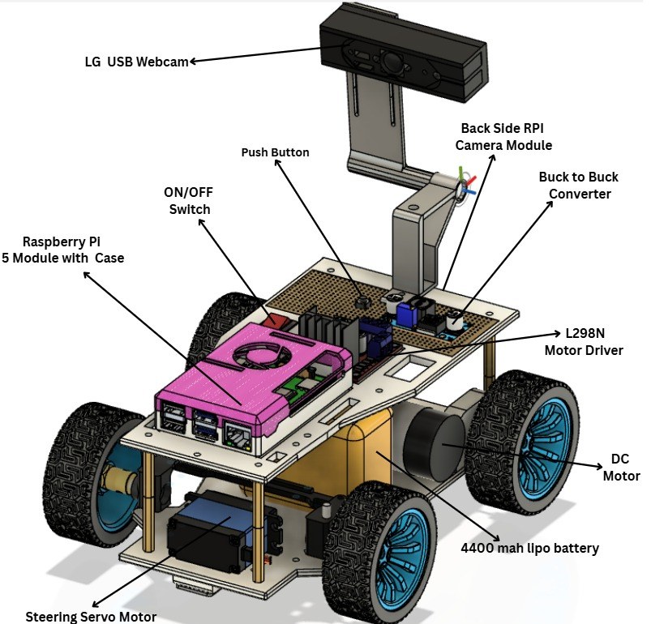

Fig.2: Assembled 3D Design of the Vehicle with Labelled Components

Once finalized, the chassis and additional mounting parts were fabricated using **Fused Deposition Modeling (FDM) 3D printing technology** with **PLA (Polylactic Acid) filament**.

**3D Printing Parameters:**

* **Scaling:** 100% (exact design measurements used).
* **Infill density:** 70% with **grid pattern**, ensuring strength while minimizing material usage.
* **Support structures:** Enabled where required, especially for the camera holders.
* **Layer thickness:** 0.2 mm.
* **Nozzle temperature:** 215°C.
* **Bed temperature:** 60°C.

This process ensured that the final chassis structure was **rigid, lightweight, and precise**, making it well-suited for mounting and supporting all components effectively.

Following the design phase, the chassis and supporting parts were **3D printed using Fused Deposition Modeling (FDM) technology** with **PLA material**, chosen for its strength, lightweight nature, and ease of fabrication. Once fabricated, the electronic and mechanical components were systematically mounted onto the printed chassis, resulting in the fully functional prototype. The completed assembly is illustrated in **Figure.3.**

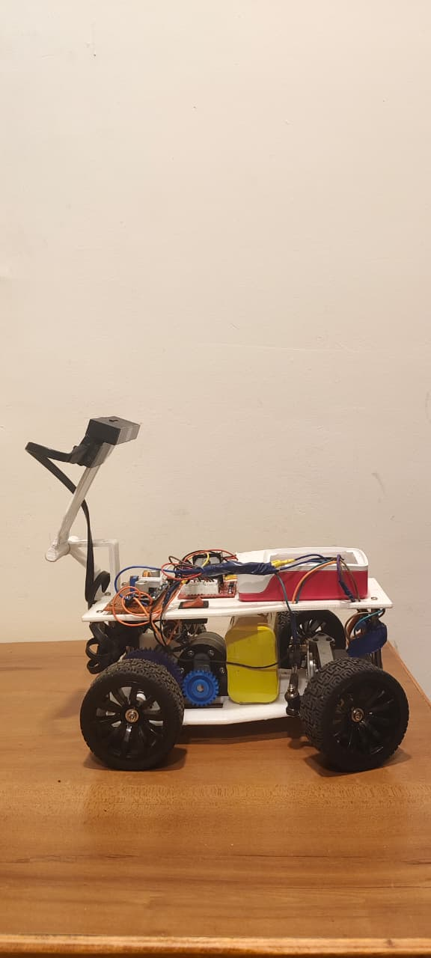

Fig.3: 3D Printed Chassis with Assembled Components

**Summary**

By combining a well-trained camera vision system, a powerful Raspberry Pi controller, and carefully selected servo and DC motors, the bot achieves efficient mobility management within the arena. The custom 3D-designed chassis, fabricated using optimized FDM printing parameters, further enhances the bot’s robustness and functionality, ensuring readiness for the Open Challenge and Obstacle Challenge rounds.